**Career Skills Assessment 1**

iConsultancy

Team 1

May 8, 2025

INDEX

**1.0 Executive Summary 3**

1.1 High-Level Project Overview 3

1.1 Objectives 3

1.2 Key Outcomes 3

**2.0 Introduction 4**

2.1 Client Background 4

2.2 Industry Background 4

2.3 Project Scope 4

**3.0 Methodology 5**

3.1 Process 5

3.2 Tools 5

3.3 Information Gathering Techniques 5

**4.0 Findings and Deliverables 6**

4.1 Findings 6

4.2 Deliverables 6

**5.0 Recommendations 6**

**6.0 Appendices 7**

# 

# 

# 

# 1.0 Executive Summary

## 1.1 High-Level Project Overview

This project, conducted in partnership with the iConsultancy at the University of Maryland, seeks to address a key challenge faced by the College of Information: a lack of visibility and connection between student skill sets and industry opportunities across Maryland. Our team is developing a skills matrix, conducting workforce research, and creating visual infographics to clearly communicate the value of the college's academic programs. These deliverables will serve as tools to educate both employers and students, ultimately supporting job placement, employer engagement, and broader workforce development goals.

## 1.1 Objectives

The main objectives of this project are:

* Identify and document the key skills and competencies taught in three undergraduate programs within the College of Information.
* Align those skills with current and emerging workforce needs in the state of Maryland.
* Raise awareness among students about diverse career opportunities related to their skillsets.
* Improve employer understanding of the talent produced by the College of Information.

## 1.2 Key Outcomes

Key outcomes expected from this project include:

* A skills matrix that transparently maps program learning outcomes to applicable workforce needs.
* A targeted report identifying relevant, often-overlooked career paths for graduates.
* Engaging visual infographics designed to inform and attract both students and employers.
* A foundation for continued efforts in aligning education with professional demand across Maryland.

# 2.0 Introduction

## 2.1 Client Background

Founded in 2019, the iConsultancy is a small but impactful organization with a team of 2–3 employees. Operating within the University of Maryland, it engages undergraduate and graduate students in real-world projects without formal employment or legal obligations under Sponsored Course Agreements. As part of the fastest-growing college at UMD, the iConsultancy manages over 150 experiential learning projects annually, supporting the professional development of approximately 700 students. Its mission is to prepare students for the workforce by cultivating in-demand skills and helping employers recognize the value of Information Science majors. Its unique value lies in blending academic insight with hands-on experience, delivering mutual benefits for students and industry partners alike.

## 2.2 Industry Background

iConsultancy operates at the intersection of consulting, higher education, and information services. It plays a leading role in experiential learning by connecting students with organizations in need of information-based solutions. The broader industry is shaped by a growing demand for data-driven decision-making, user-centered design, and technological innovation, which are all areas where iConsultancy is embedded. It serves a wide range of public and private sector clients, offering services in UX/UI, data visualization, information management, and web development. With industry trends leaning toward agile, skills-based workforce development and digital transformation, iConsultancy is well-positioned to continue growing as a bridge between academia and real-world impact.

## 2.3 Project Scope

This project aims to strengthen the visibility of student skill sets developed within the College of Information. Our team will develop a matrix that maps skills and knowledge to the learning outcomes of three undergraduate programs in the College of Information: Information Science, Information Design, and Social Data Science. The project will also involve researching workforce needs across Maryland, identifying relevant career paths, especially in emerging industries, and highlighting job roles that are often overlooked but align with the college’s training. Finally, our team will design infographics to help students and employers better understand how these skills meet critical workforce demands.

2.4 Project Goals

This project opens the door for several impactful improvements that can strengthen the connection between the College of Information, its students, and the professional world. Some of our goals include:

* **Showcasing student skill sets**: Such as through the use of skills matrices, visual summaries, a report that clearly communicates the competencies students gain through the program.
* **Increasing recruiter engagement**: Providing industry partners with a clearer understanding of the value Information College students can bring to diverse roles beyond typical data positions.
* **Broadening student career awareness**: Helping students see the wide range of career paths available to them, including UX/UI, information management, and tech consulting, based on their training.
* **Strengthening industry partnerships**: Using these insights to build new relationships with Maryland-based employers, nonprofits, and government agencies.
* **Supporting workforce development**: Enhancing the college’s contribution to Maryland’s growing need for skilled professionals by aligning student capabilities with market needs.

# 3.0 Methodology

## 3.1 Process

To ensure a systematic approach, we divided the project into four main phases: workforce demand research, data analysis, program skill mapping, and application and visualization. Each phase contributed to building a robust foundation for the final deliverables.

## 3.2 Tools

We utilized publicly available resources such as Maryland.gov and local labor statistics websites to source workforce data. Additionally, we referenced the University of Maryland’s College of Information website to analyze program learning outcomes as well as what job roles their programs prepare you for based on the skills taught and learned. For design and presentation, we used tools such as Microsoft Excel for organizing and cleaning data. We also used Tableau and Canva for designing and creating visually engaging infographics and visuals.

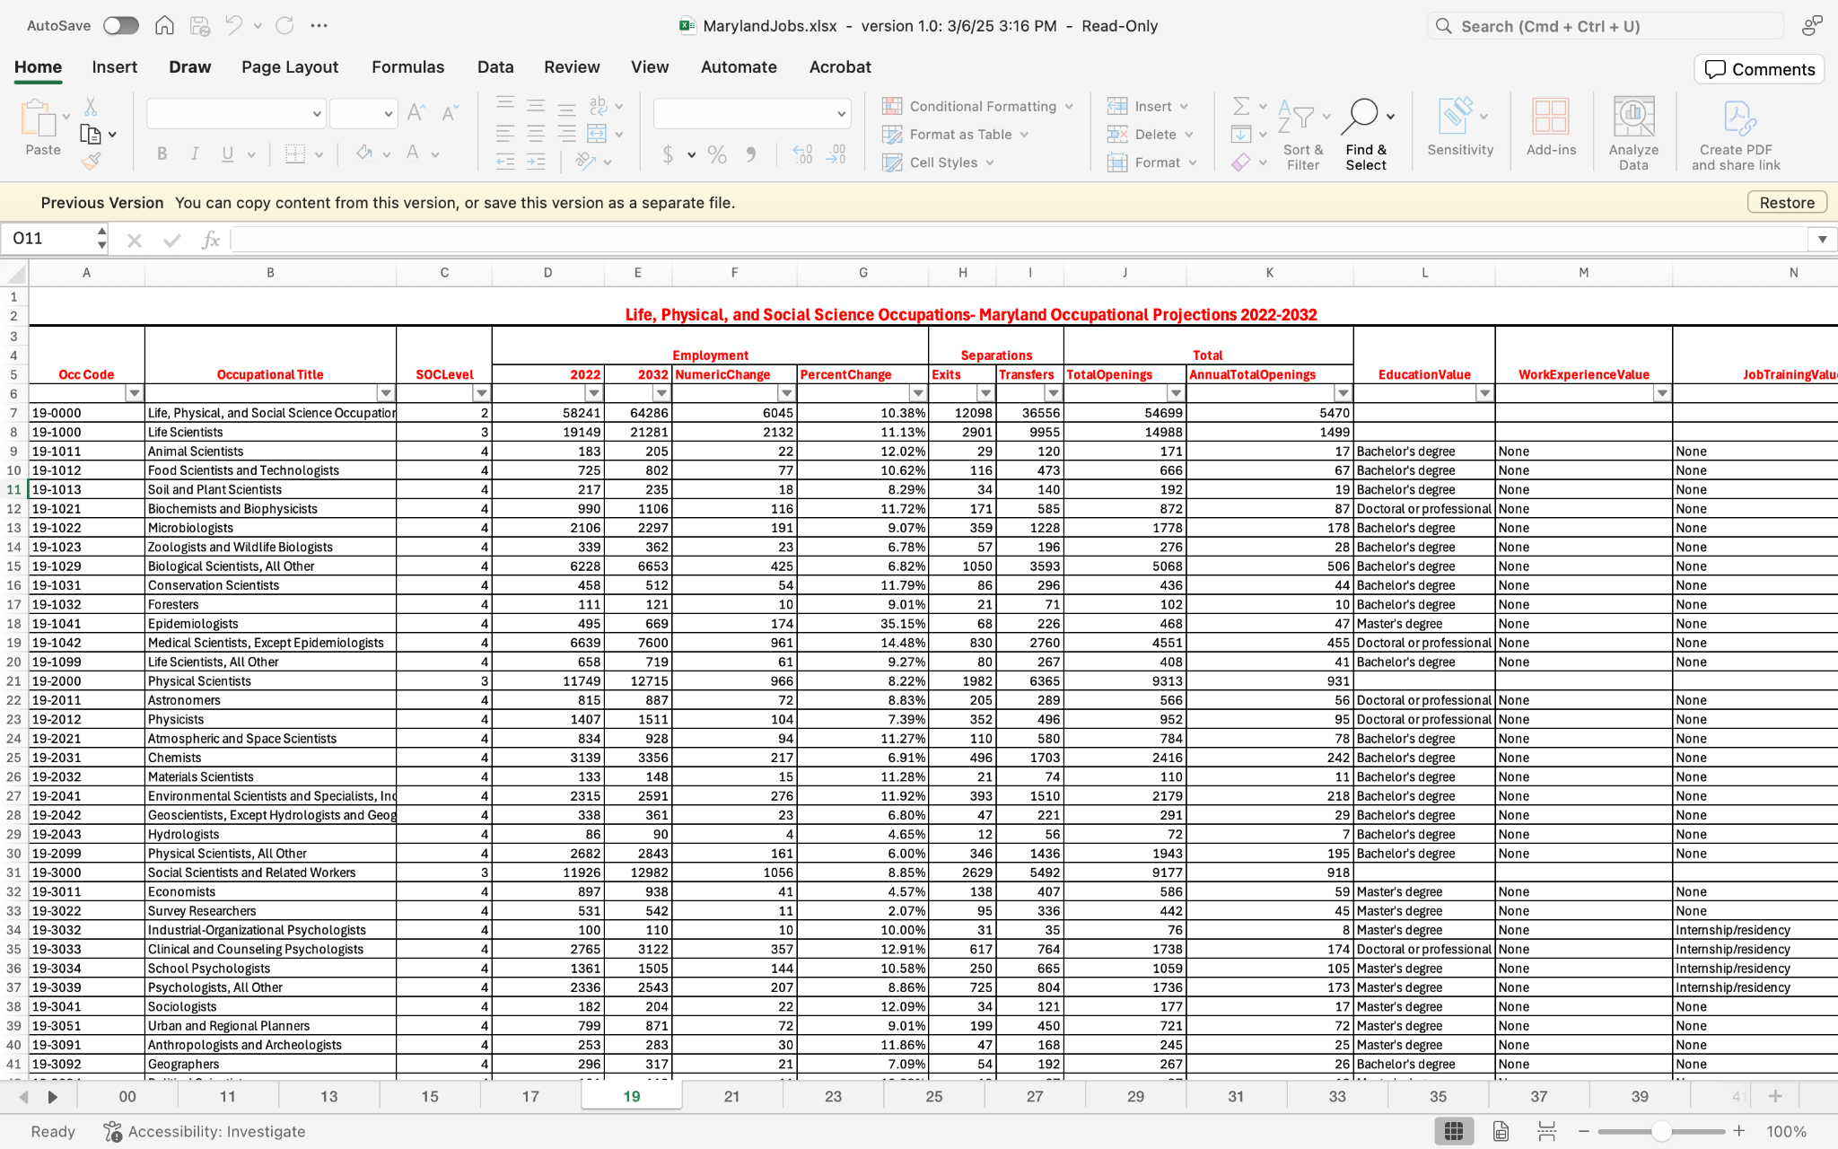To the left is the original dataset we used as a starting point for our project. The dataset contained multiple sheets dividing the jobs by industry. This required us to go in and find jobs that aligned with Information Science student skills and put that into a new dataset. Through doing this we were able to easily analyze the data and provide the client with clear and concise visualizations and figures.

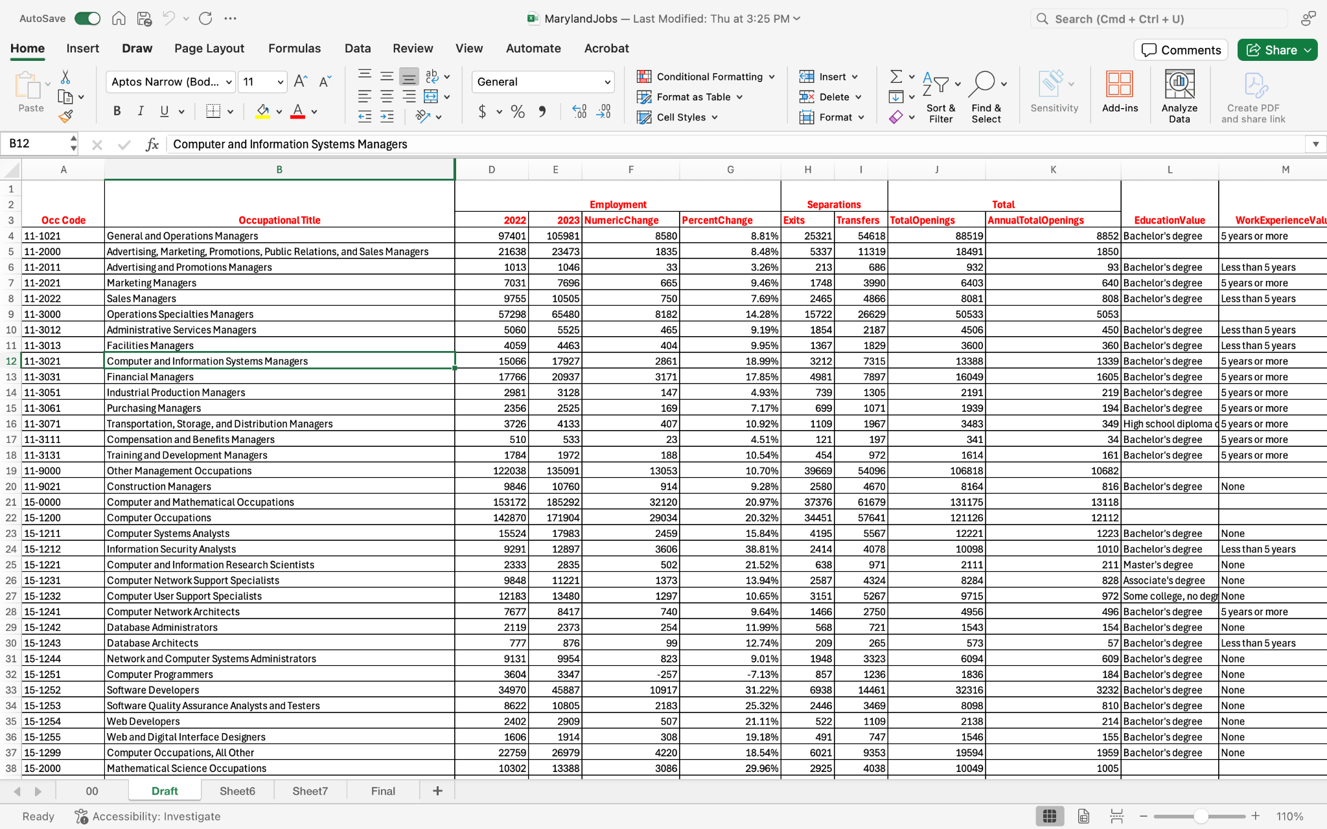

Here is the final cleaned version of the data.

## 3.3 Information Gathering Techniques

Our techniques included online research and content analysis to identify growing fields in Maryland, comparative analysis of employment trends using statistical tables, and qualitative interpretation of learning outcomes from academic programs. We also incorporated firsthand student insights to supplement official program documentation and ensure relevance to real-world applications.

# 4.0 Findings and Deliverables

## 4.1 Findings

We developed a comprehensive matrix that links specific skills to each of the three undergraduate programs. Our findings indicate that:

* All three programs, Information Science, Social Data Science, and Info & Tech Design, emphasize key technical skills such as data analysis, data visualization, and programming.
* The Information Science program provides the broadest coverage of core skills including database management and cybersecurity.
* The Social Data Science program shows strong alignment with programming and data-centric roles.
* The Info & Tech Design program emphasizes skills related to visualization and information management, positioning students for roles in UX/UI and digital design.

Our research also identified several high-growth industries and job roles in Maryland where these skills are in demand, many of which are not traditionally associated with Information Studies graduates.

## 4.2 Deliverables

Deliverables for this project include:

* A detailed skills matrix across the three programs.
* A white page that connects the skills acquired in College of Information programs with the evolving demands of the Maryland job market.
* Infographics designed to educate students and engage recruiters.

# 5.0 Recommendations

To ensure continued impact beyond this project, we recommend the iConsultancy to take the following steps:

* **Promote Materials Digitally**: Publish the skills matrix and infographics on the college’s website, particularly in areas viewed by prospective employers and students.
* **Leverage Career Services**: Work closely with UMD Career Services to integrate the materials into workshops, career fairs, and advising sessions.
* **Engage Employers**: Use the visual materials to support outreach efforts to regional employers, helping them understand the breadth of skills students acquire.
* **Educate Students**: Host short seminars or info sessions highlighting career paths beyond traditional roles, using the materials as discussion tools.

Taking these steps will help strengthen student-employer connections, raise awareness about underrecognized job paths, and ensure the college's value is fully visible to the professional community.

# 6.0 Appendices